|  |  |  |
| --- | --- | --- |
| C:\Users\Garanti1\Documents\t-c-milli-egitim-bakanligi-logo.png | **2022-2023 EDUCATION YEAR**  **……….. PRIMARY SCHOOL**  **4TH GRADE 1ST TERM 1st ENGLISH EXAM** | **Point:** |
| **NAME-SURNAME : CLASS :** |

**1) Write the directions of the cities given in the map. (4x4 =16 points)**

**east- west- north- south**

|  |  |
| --- | --- |
| * Sinop is in the …………. * Antalya is in the ………………… | * İzmir is in the ………….. * Ağrı is in the …………....... |

**Sinop**

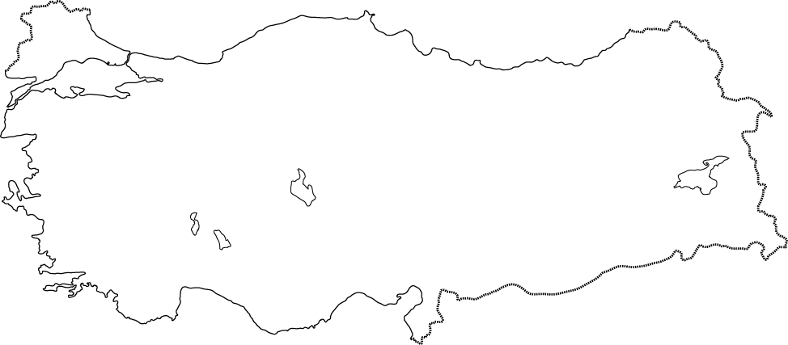

**Ağrı**

**İzmir**

**Antalya**

**2) Match the questions with their correct answers. (4 x 3 = 12 points)**

(…....) Where is Sue from? **A.** He is 12 years old.

(…....) How old is your brother? **B.** Of course, here you are.

(…....) May I take your pencil? **C.** I live in Ankara.

(..…..) Where do you live? **D.** She is from Britain.

**3) Fill in the ID CARD according to the text below. (4*3= 12 points)**



**ID CARD**

**Name**:___________________________

**Age**:,-____________________________

**Country**:_________________________

**Nationality**:______________________

**4) Circle the correct option (8x5=40 points)**

**1. ………………..**



**A)** Come in.

**B)** Stand up

**C)** Sit down

**D)** Raise your hand

**2. Look at the board.**

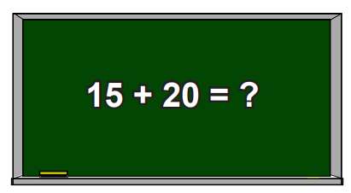

**A)** Forty-five

**B)** Thirty-five

**C)** Twenty-five

**D)** Fifty-five

**3. Can I_________ ? .**

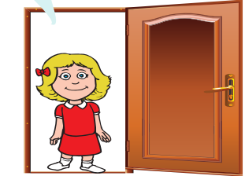

**A)** come in

**B)** open the window

**C)** take your ruler

**D)** clean the board

**4. This is my English** **_______________**

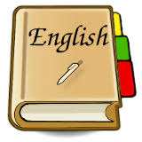

**A)** bike

**B)** book

**C)** kite

**D)** pen



**5. Tom is from ………**

**He is ……………………….**

**A)** The USA/American

**B)** Turkey/Turkish

**C)** Spain/Spanish

**D)** Germany/German

**6. Which one is WRONG? (X)**

**A)** 14+16= thirty

**B)** 45-13= thirty-two

**C)** 20+36= seventy-six

**D)** 56-15= forty-one

**7. May I take your book, please?**



**A)** Yes you may.

**B)** Of course.

**C)** Sorry, not now.

**D)** Sure.

**8. What nationality is she?**

**She is………….**



A) Russian

B) Spanish



C) Japanese

D) Turkish

**5) Read the passage. Each question is 5 points.**

**Write True (T) or False (F)**

Hi! I’m Nadal. I’m 34 years old. I’m from Spain. I live in Barcelona. I’m a famous tennis player. Tapas is my favourite food in Spain.

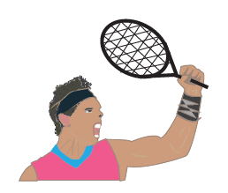

*His name is Nadal. _____

*Nadal is from France. _____

*He is thirty-four years old. _____

*Nadal is a football player. _____